INFORMATICS INSTITUTE OF TECHNOLOGY
In Collaboration with
UNIVERSITY OF WESTMINSTER


ALUMNI INFLUENCERS – ADVANCED SERVER-SIDE WEB PROGRAMMING COURSEWORK

A dissertation by
Mr. Mihan Fernando
W1953506 | 20220683

Module leader
Mr. Indrajith Ekanayake

Submitted in partial fulfilment of the requirements for the B.Eng. (Hons) Software Engineering degree at the University of Westminster.

April 2026

Table of Contents

1. Executive Summary 1
2. High-Level System Architecture 1
3. Load Balancing Strategy 3
4. MVC (Service-Oriented) Architecture 4
5. Database Design – Users & Authentication 6
6. Database Design – Alumni Ecosystem 8
7. Database Design – Bidding & Sponsorship 9
8. Routing Architecture 10
9. API Endpoints – Authentication & Users 11
10. API Endpoints – Alumni Operations 12

https://github.com/mihan2002/ADS-CW
List of Figures
Figure 1High-Level System Architecture: 3
Figure 2: Load-Balancing Diagram 4
Figure 3:MVC (Service-Controller) Architecture 6
Figure 4:Users & Authentication 8
Figure 5:Alumni Ecosystem 9
Figure 6:Bidding & Sponsorship 10
Figure 7:Routing Ecosystem Diagram 11

LIST OF TABLES
Table 1:Authentication & Users 11
Table 2:API Endpoints – Alumni Operations 12

1. Executive Summary
This report presents the backend architecture of the system, designed using a Service-Oriented MVC architecture to ensure scalability, maintainability, and security.
The backend is implemented using Node.js with Express.js, supported by a MySQL relational database and an ORM layer for structured data access. The system is built as a headless REST API, meaning it serves multiple client applications (web/mobile) through standardized JSON responses.
The architecture emphasizes:
- Clear separation of concerns (Routing, Controllers, Services, Database)
- Secure authentication and authorization mechanisms
- Scalable infrastructure with load balancing support
- Modular and extensible routing design
The system handles key functionalities such as:
- User authentication and profile management
- Alumni data handling with relational structures
- Blind bidding system for feature-day selection
- API-based integration for external clients

2. High-Level System Architecture
The system follows a layered architecture where client applications interact with backend services through an API gateway or load balancer.
Architecture Overview
- Clients (Web / Mobile) send HTTP requests
- Requests pass through a Load Balancer
- Distributed backend instances process requests
- Business logic is handled in service layers
- Data is stored and retrieved via ORM from MySQL
Key Components
- Client Layer – User interfaces consuming APIs
- API Gateway / Load Balancer – Distributes traffic
- Backend Servers – Stateless Express instances
- Service Layer – Business logic execution
- Database Layer – Persistent storage
This architecture ensures horizontal scalability and high availability.
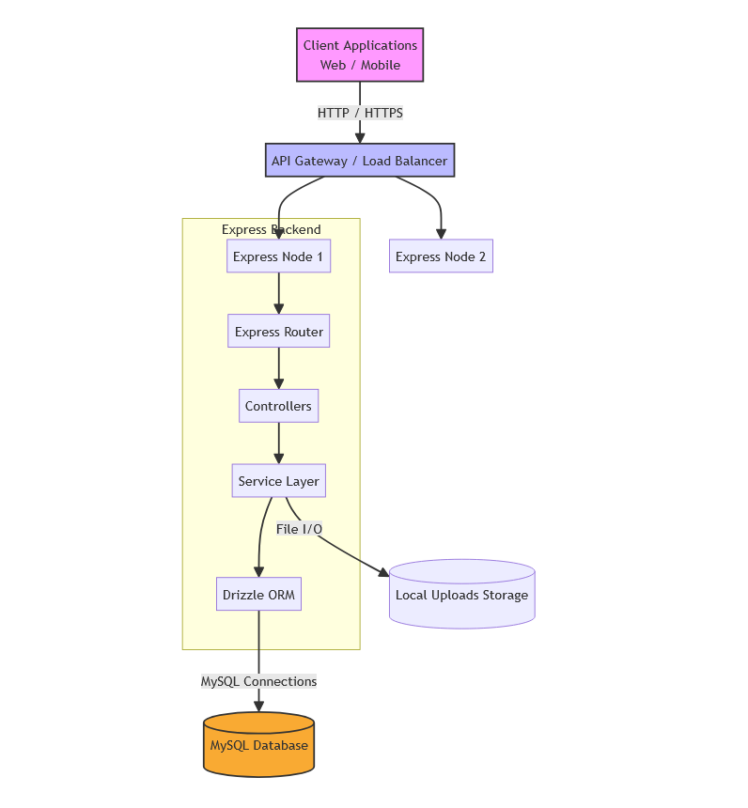
Figure 1High-Level System Architecture:

3. Load Balancing Strategy
To handle increasing traffic, the system uses a load balancing mechanism that distributes incoming requests across multiple backend instances.
How it Works
- A load balancer (e.g., Nginx or cloud-based LB) receives requests
- Requests are distributed using strategies like:
  - Round Robin
  - Least Connections
- Each backend instance:
  - Processes requests independently
  - Connects to the same shared database
Advantages
- Improved performance under high traffic
- Fault tolerance (if one server fails, others continue)
- Horizontal scalability
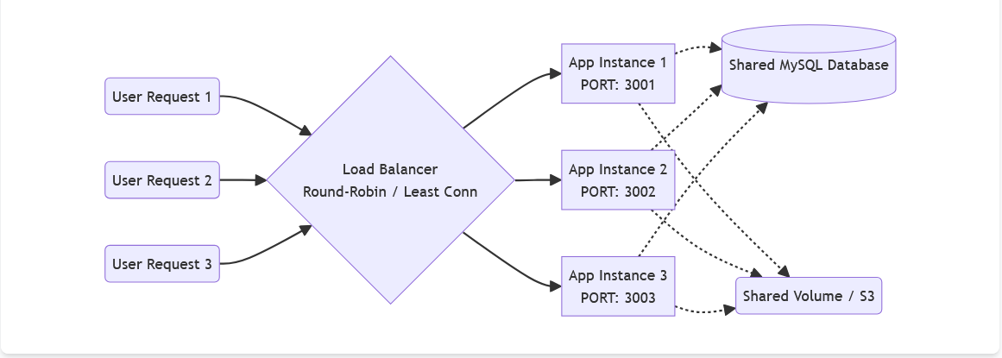
Figure 2: Load-Balancing Diagram

4. MVC (Service-Oriented) Architecture
The backend follows an extended MVC architecture, enhanced with a Service Layer.
Layer Breakdown
Routing Layer
- Defines API endpoints
- Directs requests to appropriate controllers
Middleware Layer
- Handles authentication and validation
- Protects endpoints from unauthorized access
- Sanitizes input data
Controller Layer
- Handles request/response lifecycle
- Calls service methods
- Does NOT contain business logic
Service Layer
- Contains core business logic
- Processes operations like bidding, authentication, and data transformations
Model Layer (ORM)
- Defines database schemas
- Handles queries through ORM
Benefits
- Clean and maintainable codebase
- Easy testing and debugging
- Scalable for future features
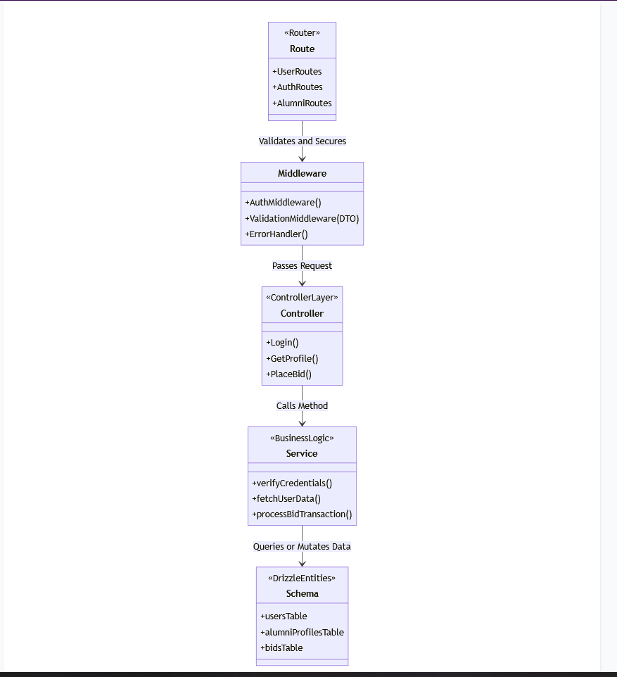
Figure 3:MVC (Service-Controller) Architecture

5. Database Design – Users & Authentication
The system uses a relational database (MySQL) designed using normalization principles.
Core Tables
Users
- Stores user credentials and identity
- Fields include:
  - id
  - email
  - password_hash
  - role
  - timestamps
Email Verification Tokens
- Used for account verification
- Includes expiry and usage tracking
Password Reset Tokens
- Enables secure password reset
- Time-limited tokens
Key Features
- Secure password storage using hashing
- Token-based verification mechanisms
- Prevention of unauthorized access
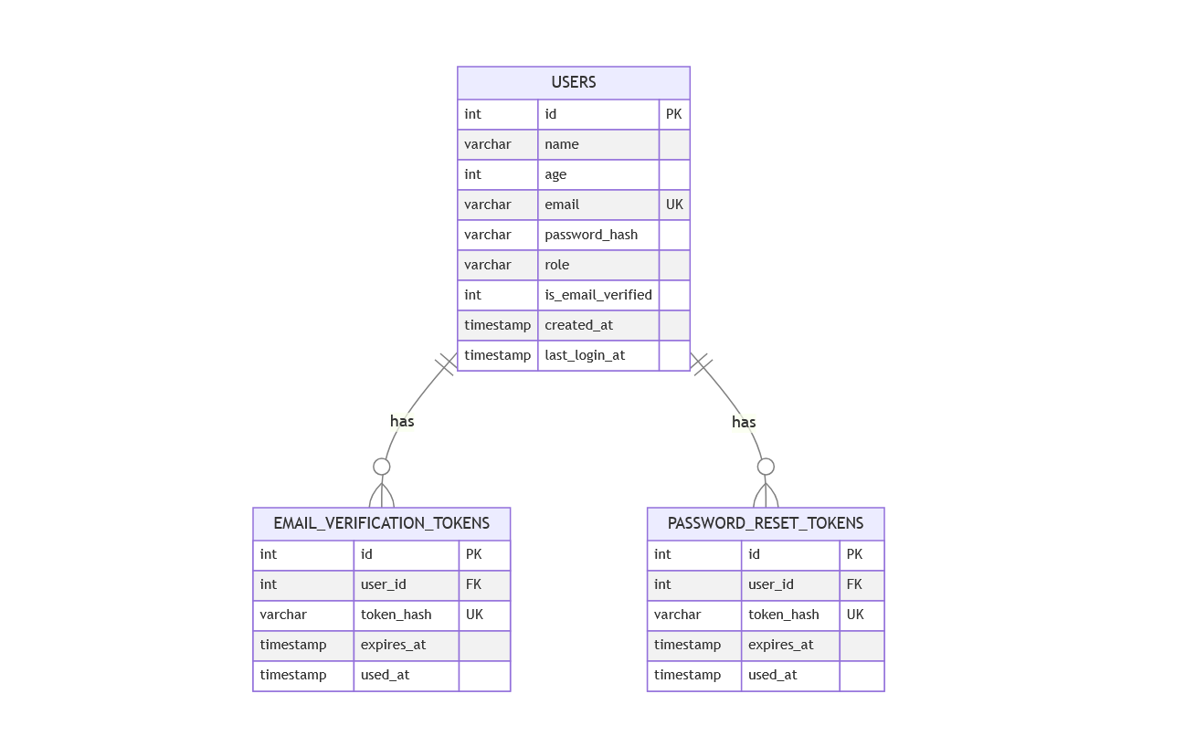
Figure 4:Users & Authentication

6. Database Design – Alumni Ecosystem
The alumni system is designed using 1-to-many relationships to maintain normalization.
Entities
- Alumni Profiles
- Degrees
- Certifications
- Licenses
- Professional Courses
- Employment History
Design Principles
- Each entity is stored in a separate table
- Linked via foreign keys
- Avoids redundant data storage
Advantages
- Eliminates data duplication
- Ensures consistency
- Supports flexible querying
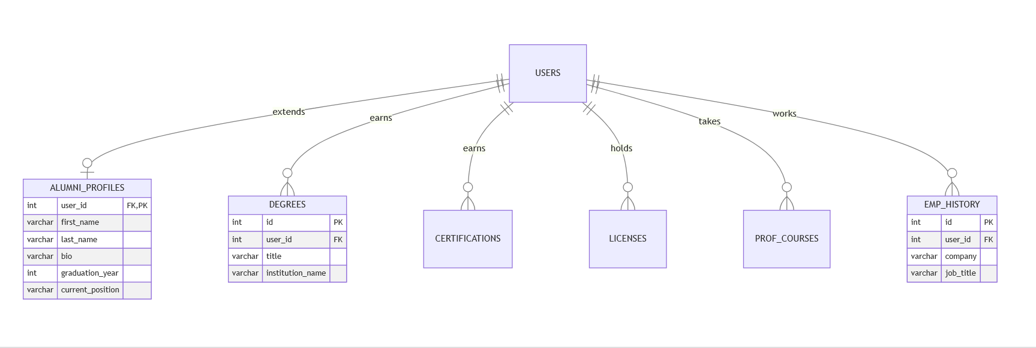
Figure 5:Alumni Ecosystem

7. Database Design – Bidding & Sponsorship
The system includes a blind bidding mechanism and sponsorship model.
Blind Bidding System
- Users submit bids for feature slots
- Other bids are hidden (blind system)
- Highest bid wins
Key Tables
- Bids
  - Stores user bids and status
- Feature Days
  - Stores winning bids for each day
- Sponsors & Offers
  - Supports sponsorship interactions
Key Rules
- Users cannot see competing bids
- Bids can only be increased
- System automatically selects winners
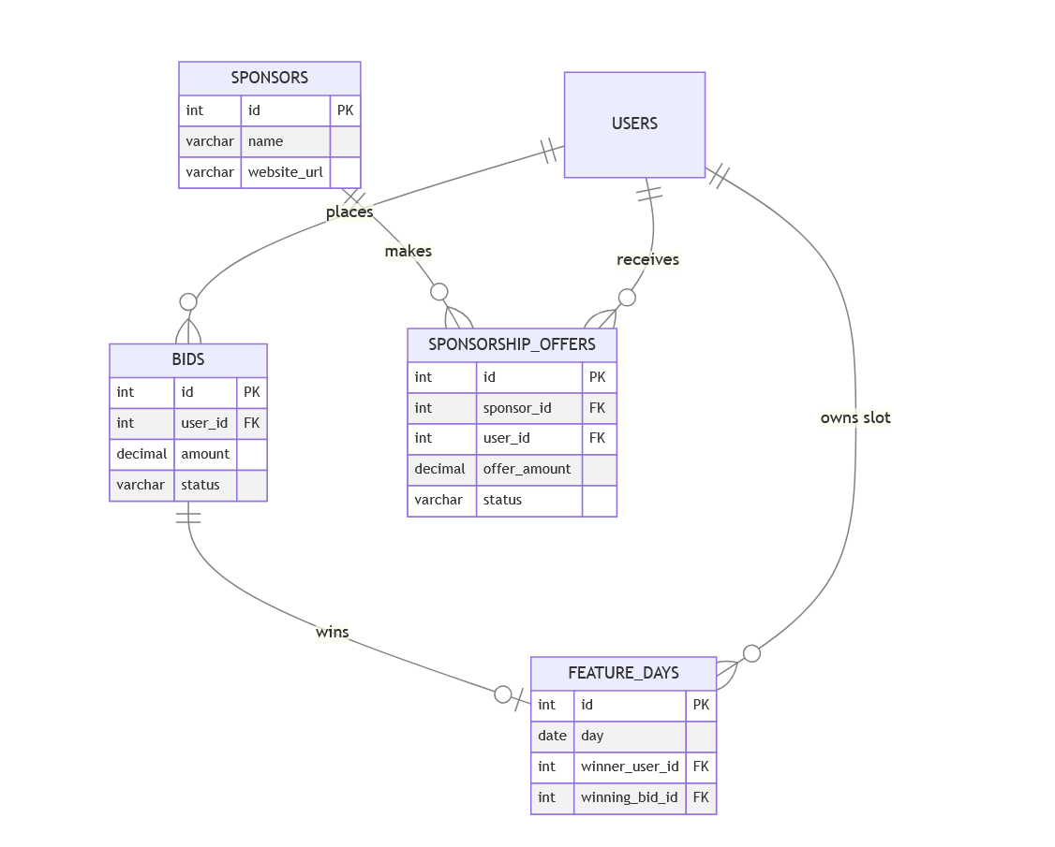
Figure 6:Bidding & Sponsorship

8. Routing Architecture
The backend uses a modular routing system for better organization.
Routing Structure
- /api/auth → Authentication
- /api/users → User management
- /api/alumni → Alumni operations
- /api/bidding → Bidding system
- /api/system → System utilities
Features
- Logical separation of routes
- Scalable structure for new modules
- Clean API design
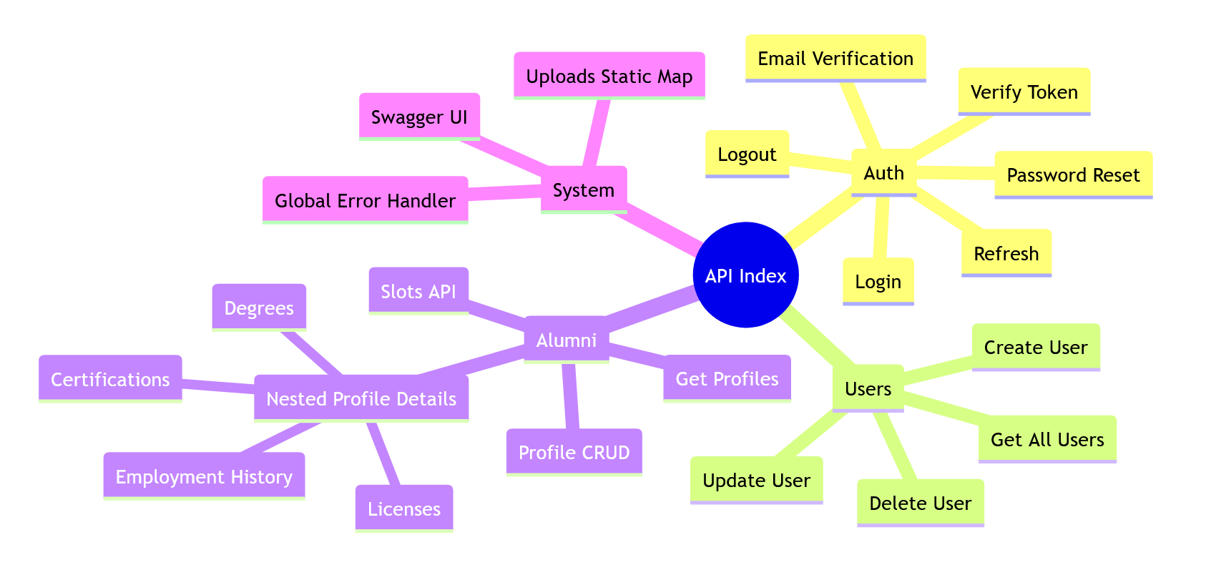
Figure 7:Routing Ecosystem Diagram

9. API Endpoints – Authentication & Users
Key Endpoints
Method | Endpoint | Description
POST | /api/auth/login | Authenticate user
POST | /api/auth/refresh | Refresh access token
POST | /api/auth/verify-email | Verify email
POST | /api/auth/reset-password | Reset password
GET | /api/users | Get all users
POST | /api/users | Create new user
Table 1:Authentication & Users

10. API Endpoints – Alumni Operations
Key Endpoints
Method | Endpoint | Description
GET | /api/alumni | Get all alumni
GET | /api/alumni/:userId | Get detailed profile
POST | /api/alumni/:userId/profile | Create/update profile
POST | /api/alumni/:userId/degrees | Add degree
POST | /api/alumni/:userId/certifications | Add certification
DELETE | /api/alumni/:userId/profile | Delete profile
GET | /api/alumni/slots/tomorrow | Check slot availability
Table 2:API Endpoints – Alumni Operations

